

MASTER OF COMPUTER and INFORMATION SCIENCES

408216
Data Mining & Knowledge Engineering

Weka Workshop

Introduction

WEKA (Waikato Environment for Knowledge Acquisition) is a GUI program that allows you to run ML algorithms over data sets. It trains the chosen algorithm, and then tests it and reports the accuracy of the resulting rule set.

In this lab you will use the workbench to compare some ML algorithms, to get a feel for how they compare, and how they perform differently on different data sets.

Selecting a dataset: the “Preprocess” window

The window you see before you is the “preprocess” pane. Here you can select a data file to work on. Click on “open file”, and select the “data” directory. You will see a list of “arff” files. These contain the data in WEKA’s proprietary format. You may like to edit one in a text editor to see what they look like. They contain the following data:

• Contact-lenses.arff
- the contact lenses data set similar to that used in lectures. This data set completely enumerates the problem domain.
• CPU.arff
- data set for numeric prediction: all but one of the attributes are numeric
• Iris.arff
- classifies iris flowers into one of three varieties, using four numeric attributes (sepal and petal lengths and widths). One class is linearly separable, and most ML systems can predict this data set to a high (>90%) level of accuracy

Labor.arff
- final settlements in labor negotitions in Canadian industry. Class is “good” or “bad”, attributes are various features of a labor contract. Both numeric and nominal attributes are used, many of which have missing values.
• Soybean.arff
- classifies diseases of soybean plants, according to various symptoms the plant displays. All attributes are nominal, some have missing values.
• Weather.arff
- numeric attributes for temperature, wind and humidity
• Weather-nominal.arff
- as above, but all attributes are nominal

- Select the “weather-nominal” dataset.

The panel at the top left of the screen reports the size of the data set and the number of attributes, including the class.

The panel in the centre left of the screen displays the attributes. The last one in the list is the default class (this may be modified in the “classify” pane). To find out more about an attribute, click on its name. The centre right panel displays the following information about the attribute:

- Type (nominal, binary or numeric)
- Number of examples for which this attribute is missing
- The number of distinct values (useful for numeric data)
- The number of values which are unique (i.e. only a single example has this attribute value)
- Each attribute value, and the number of examples with this value.

It is also possible to filter the data (e.g. turn numeric attributes into discrete ones.)

Running the ML algorithms: the “classify” window

The purpose of this pane is to run one or more ML algorithms over the data, and see how well they perform. Click on the “Classify tab to bring up this pane. Here, you can run any of 41 different ML schemes over the data. You choose the one you want by clicking on the name of the classifier at the top left, and then selecting from the list.
Note that some of the entries, such as “bagging” and “stacking” are not ML algorithms themselves. Rather, they are methods that are used in conjunction with ML algorithms to boost their accuracy.

The algorithms you will explore are (feel free to experiment with others):
- ID3 – a decision tree classifier
- Naïve Bayes – classifies examples by calculating the probability of each class given each attribute value in the new example, and combining these probabilities. The class with the highest probability is chosen.
- IB1 – pure nearest neighbour
- J48 – another version of the decision tree classifier that does tree pruning
- One-R – simple algorithm that simply finds the most predictive attribute, and uses just that attribute to predict class

The “test options” panel displays how the algorithm will be tested. There are three options:
- Supplied test set – a dedicated test set is available. The algorithm will be trained on the entire dataset, then tested using the specified test set.
- n-way Cross-validation. The training set will be split n times, such that the test set consists of 1/n of the examples, and the training set consists of the rest. The default is 10-way validation
- Percentage split – p% of the data is used to train the system, and the rest is used for testing.

Of these three, n-way validation is the most common, and gives the best picture of accuracy.

1. Select the classifier ‘id3’
2. Set up the testing for 10-way cross-validation
3. Click “start”. The algorithm is now run.

At the conclusion of the test run, all 14 training examples will have also been used for testing. The “classifier output” panel displays what happens. The output varies depending on the ML algorithm being used, but in general it displays:
- Summary information about the data set;
- The model (e.g. decision tree) built, and the level of fit with the data observed
- Summary test statistics. Of particular importance are the percentage of correctly and incorrectly classified examples
- A “confusion matrix”. This shows exactly how the examples were classified, so that the false positives (chose this class instead of the correct one) and negatives (failed to choose this class) can be identified.

4. What is the accuracy of ID3 on the weather dataset?

5. Now select the classifier “IB1”. This is a raw nearest-neighbour classifier.
Rerun the test using this classifier. How does the accuracy compare?

6. Complete the following table.

Dataset | Classifier | Percent correct
Weather-nominal | ID3
 | Naï ve Bayes
 | IB1
 | J48
 | One-R
Iris | ID3
 | Naï ve Bayes
 | IB1
 | J48
 | One-R
Labor | ID3
 | Naï ve Bayes
 | IB1
 | J48
 | One-R
Soybean | ID3
 | Naï ve Bayes
 | IB1
 | J48
 | One-R

You should have noticed that the same algorithm does not win every time. In particular, J48, the state-of-the-art version of ID3, performs appallingly on the weather-nominal dataset. This is because it is performing error pruning, and trying to estimate the reduction in “error” each prune effects. In fact, there are no errors in this dataset, so it is pruning out genuine tests. Experiment with the settings for J48 to gain some understanding of how error pruning can be bad. In particular, modify the parameter “MinNumObj”, which tells J48 how many examples a rule must cover before it is considered valid. You might also like to try modifying the confidence factor. Note that the “model” built by j48 is always the same. This is because this is the “raw” model built from the entire data set.

7. What happens to the accuracy as you modify various parameters?

8. Recall that both Labor and Soybean datasets contain missing values. Which appears to be the best algorithm for handling missing values?

Visualisation

The “visualise” tab lets you observe how the classes are spread across the various attributes. You can select an attribute for each of the X and Y axes, and the coloured crosses indicate the class of each data point. NOTE: the “jitter” control spreads the data out. If this is set to the minimum value, instances with the same value of the attribute will be plotted on top of each other, and hence data will be obscured.

Additionally, on the right hand side the set of scatter plots show the distribution of class for each individual attribute (the top one is for the “instance number’, i.e. the record number). Left-clicking on a bar selects this attribute as the X axis of the main plot. Right-clicking it selects it for the Y axis.

1. Select the “Iris” dataset
2. Observe the spread of the classes across each of the four attributes
3. One of the classes is linearly separable with respect to two of the attributes (i.e. it is completely contained within a single value range). Which class is it, and which attributes? Does this tell you anything about the difficulty of classifying this dataset?
4. Repeat for the soybean data. This should give you some idea why OneR performs so badly on this dataset.

Neural Networks
NOTE: Neural Networks will be covered later on in lectures in the course

A neural network is a generic learning system. NNs accept each attribute as input, and
feed them into artificial “neurons”, which combine the input data numerically and
produce an output. NNs learn by modifying the weighting of each input, such that
each attribute has more or less importance than others in the final outcome. The
simplest NN consists of a set of “perceptrons”, one per class:

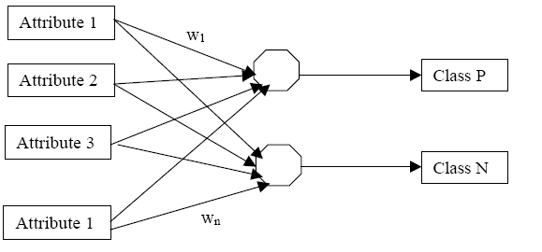

More complex networks may have “hidden layers” – neurons that are not connected
directly to a class, but instead feed into other neurons, for example (3 hidden layers):

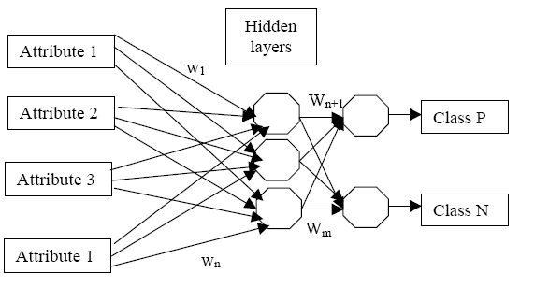
How many hidden units should you use? This is the open question with NNs – every
problem is different. There are also other “topologies”, such as multiple layers of
neurons, rings, partially connected nets (the above net is fully connected) etc.

1. To illustrate this point, experiment with the classifier
“weka.classifiers.neural.neuralnetwork”. Try it on the domains listed below,
altering only the “Hidden layers” parameter. NOTE: a value of “a” (the
default) means one per input attribute. What is the best number of hidden
layers for each domain?

2. Setting “GUI” to true in the parameters causes WEKA to show you the
network. Try this feature. You will need to click “start” and “accept” once for
the initial build, plus once for each cross-validation run.

3. NOTE: Neural Networks can take a long time to train! These domains have
been selected because they are small. Try building a network for “Soybean” to
see how the processing time can rise.

Dataset | Classifier | Percent correct
Weather-nominal | A (4)
 | 0
 | 1
 | 2
 | 3
Iris | A (4)
 | 0
 | 1
 | 2
 | 3
Labor | A (4)
 | 0
 | 1
 | 2
 | 3
Soybean | A (4)
 | 0
 | 1
 | 2
 | 3

You should observe that the way the behaviour changes when the number of hidden networks is altered is far from consistent, even for these very simple domains. Hence for “real” learning tasks, the biggest job is usually trying to find the right topology for the problem. There has been much research into making Neural Networks learn the topology too (adaptive Neural Networks).

